Directions to Beachwood Community Center
147 Compass Ave, Beachwood NJ 08722
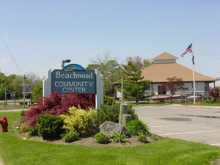
From the North:
- Take Exit 80, toward CR-530/Toms River/US-9 S/ Beachwood (stay in far right lane)
- Turn LEFT onto Admiral Ave/CR-621
- Turn RIGHT onto Atlantic City Blvd/NJ-166
- Turn LEFT onto Starboard St/CR-617 (Very first LEFT after Rite Aid, by the bicycle Shop)
- Turn RIGHT onto Compass Ave/CR-617

From the South:
- Take Exit 81 toward Lakehurst Rd/Toms River
- Turn SLIGHT RIGHT onto W Water St
- Turn RIGHT onto Irons St
- Turn LEFT onto Herflicker Blvd
- Turn SLIGHT RIGHT onto NJ-166
- Turn LEFT onto Starboard St/CR-617 (Left after Rite Aid)
- Turn RIGHT onto Compass Ave/CR-617

